The University of Azad Jammu and Kashmir, Muzaffarabad

Name: Alishba Zakir
Roll No: 2024-SE-02
Course: DataBase Systems
Course Code: CS-2204
Lab: 06
Submitted To: Engr. Awais Rathore
Submitted By: Alishba Zakir
Date: Mar, 2026

Department Of Software Engineering

Filter:Part A
A filter in a database is a rule or condition used to select a specific subset of records while excluding data that does not match.
How Filters Work
- Condition Evaluation: The database tests each record against a logical expression or criteria.
- Inclusion and Exclusion: If a record makes the condition true, it stays in the results; if false, it gets left out.
- SQL Implementation: In relational databases, filtering is most commonly performed using the WHERE clause or the HAVING clause for grouped data. [1, 2]
Common Types of Filters
- Comparison Filters: Check for exact matches, greater than, or less than values (e.g., age > 18).
- Logical Filters: Combine multiple rules using operators like AND, OR, and NOT.
- Text/Pattern Filters: Search for specific words, phrases, or partial matches (e.g., names starting with a specific letter).
- Temporal Filters: Select data within specific dates or timeframes (e.g., purchases made in the last 30 days).
- Create a Databse Filter :
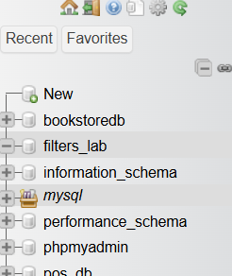
- Create Employee Table :
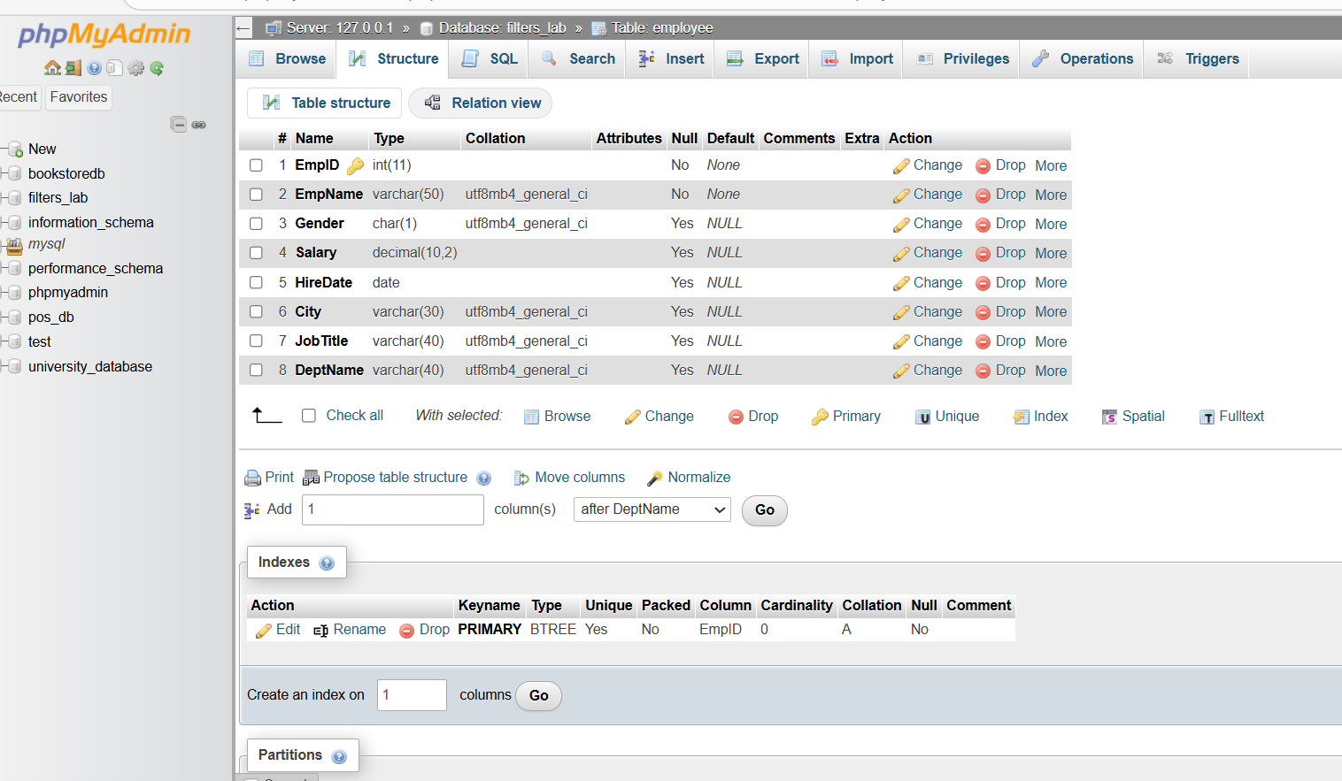
- Insert Data:
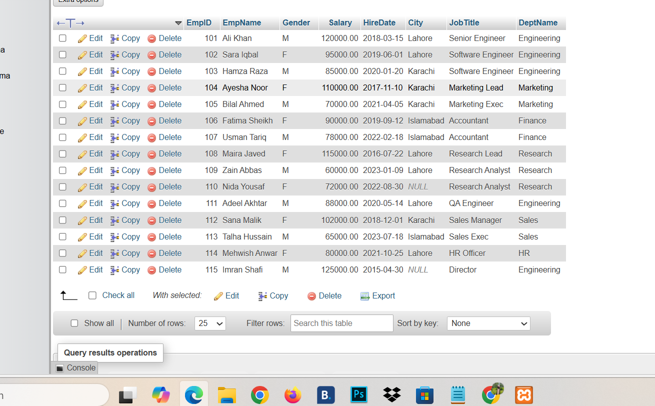
- Apply Comparision Operator :
- Comparison operators in SQL are symbols used to compare two values, expressions, or column data. They evaluate the relationship between the operands and return a boolean result (TRUE, FALSE, or UNKNOWN).
- The standard SQL comparison operators are:
- = (Equal to)
- != or <> (Not equal to)
- > (Greater than)
- < (Less than)
- >= (Greater than or equal to)
- <= (Less than or equal to)
1: Salary> 90,000.
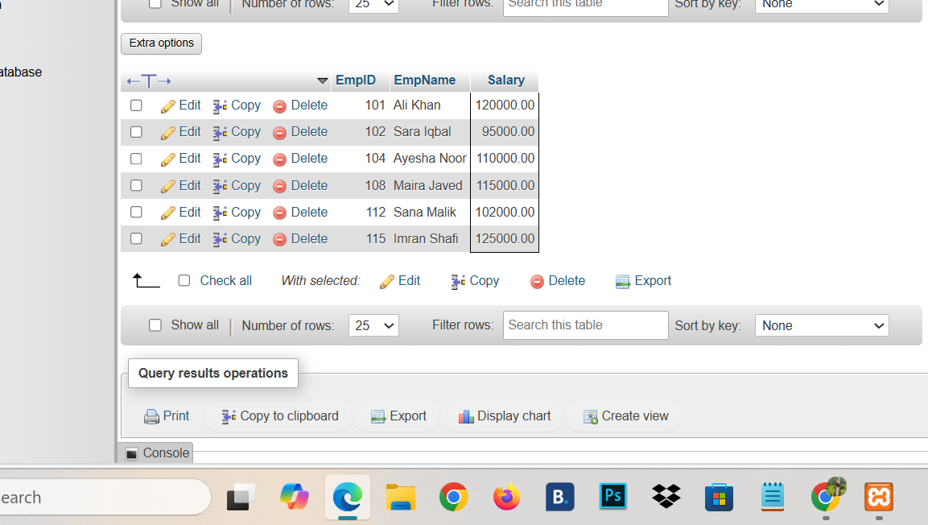
2: Salary<75,000: 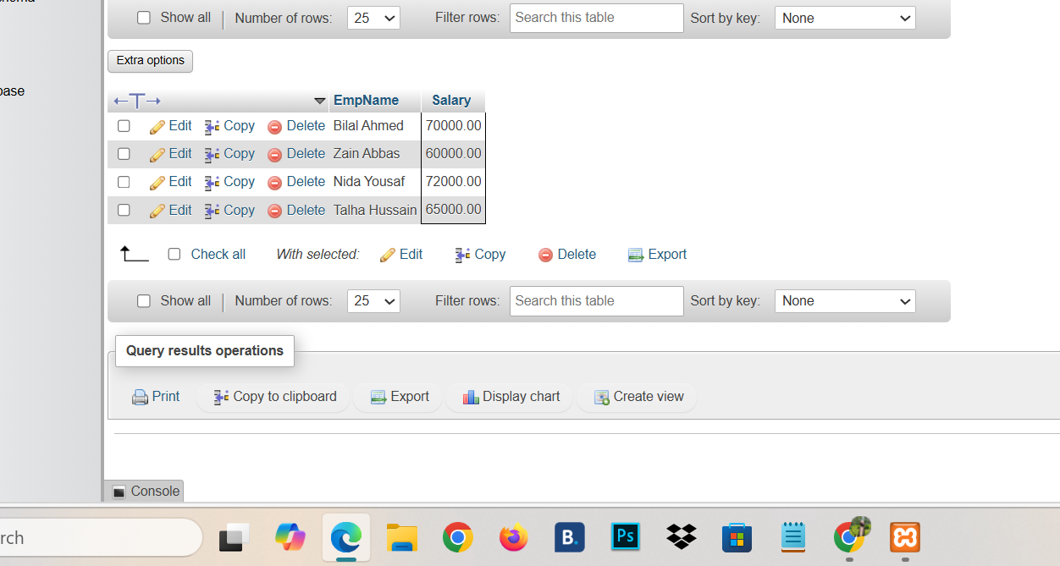
3: Show City Lahore& Salary>90,000

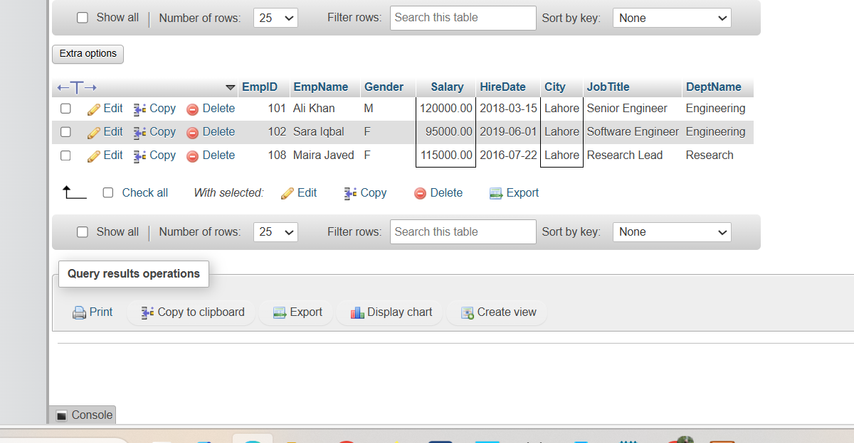

4: Show City Lahore and Islamabd:
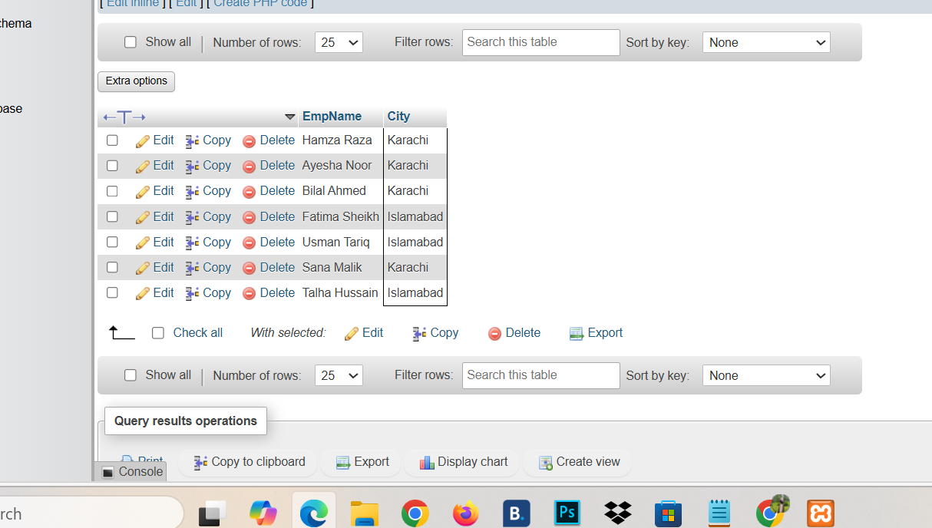
5: show Female And Dep not engineering :
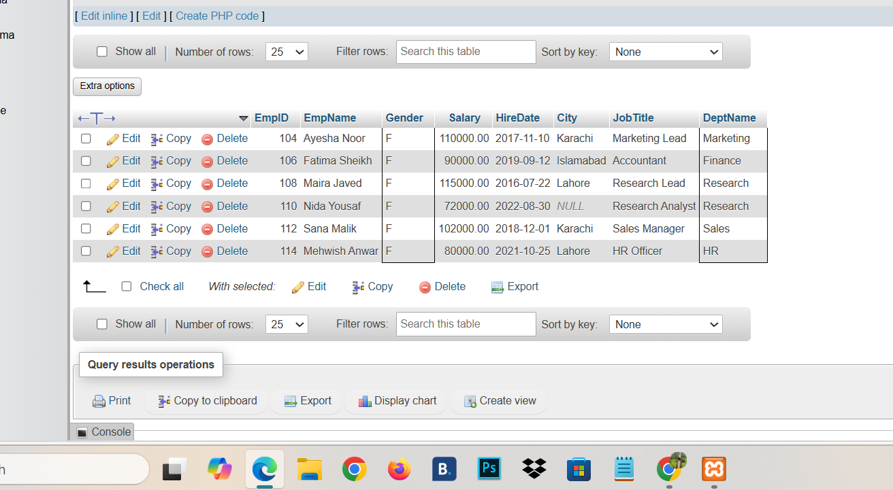
6: show employee who are male and earn 70 to 90,000:
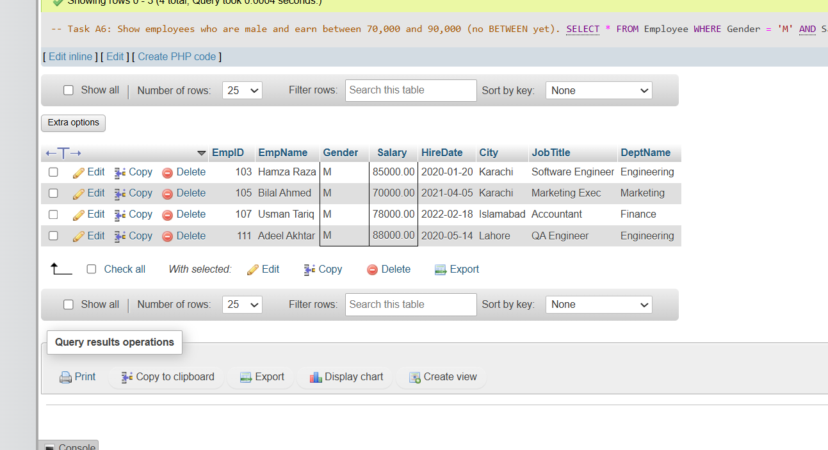
7: List Employee who are Software Engineering &earn >100,000:
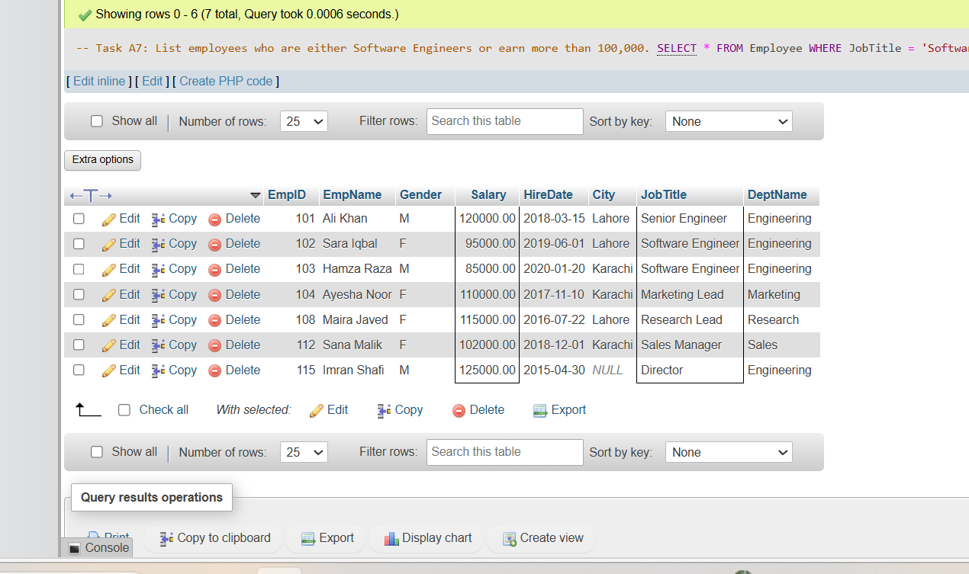
8:Find employee who are not in marketing and not earn:

